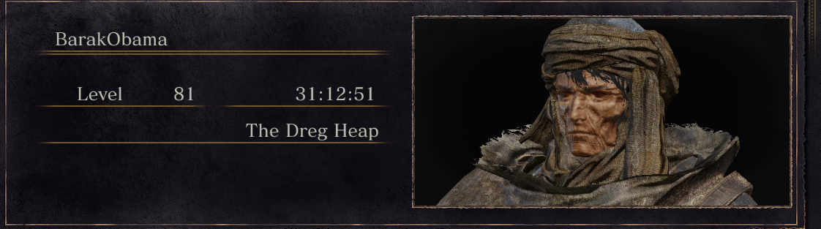Dark souls III done with nameless king and ringed city dlc